**Chapter-6**

System Model Architecture

6.1 Introduction6.2 Data Flow Diagram6.3 Rules of Governing the DFD’S6.4 DFD for UMS System6.5 Use Case Diagram6.6 Sequence Diagram6.7 Activity Diagram

**6. System Model Architecture**

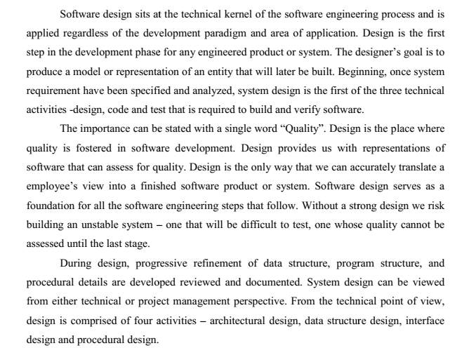**6.1 Introduction**

**6.2 Data Flow Diagram**

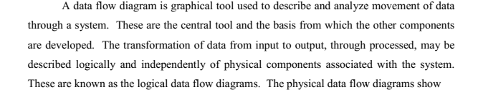

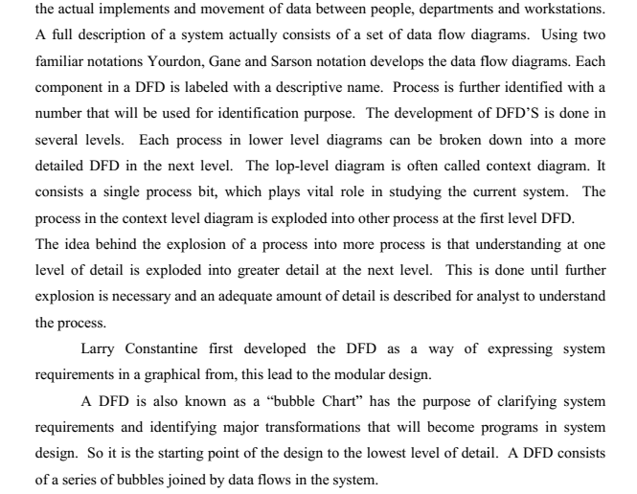

**6.2.1 DFD Symbols**

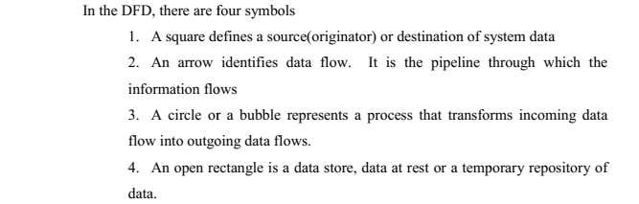

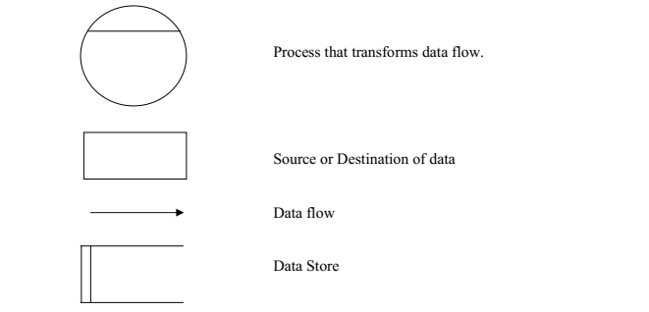

**6.2.2 Constructing DFD**

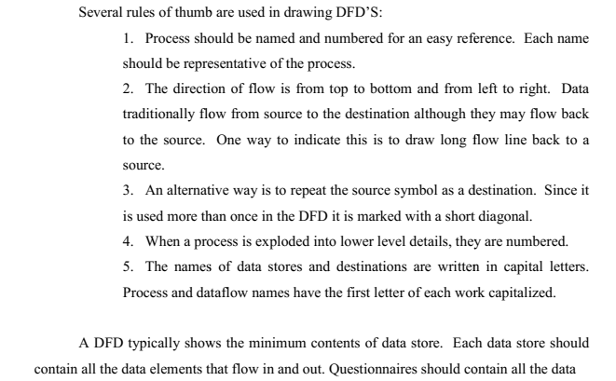



**6.2.3 Silent Feature of DFD**

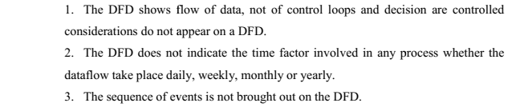

**6.2.4 Types of DFD**

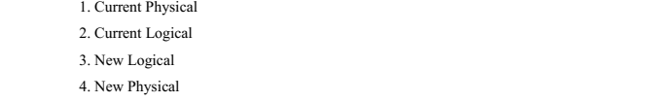

**6.2.4.1 Current Physical**

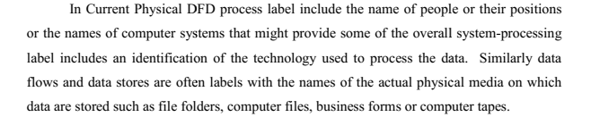

**6.2.4.2 Current Logical**

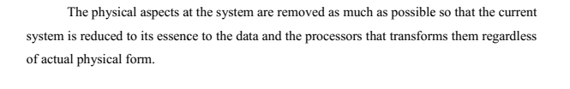

**6.2.4.3 New Logical**

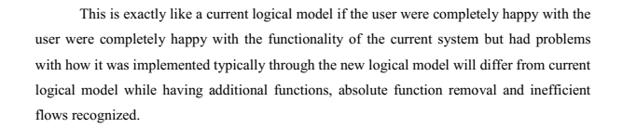

**6.2.4.4 New Physical**



**6.3 Rules of Governing the DFD’S**

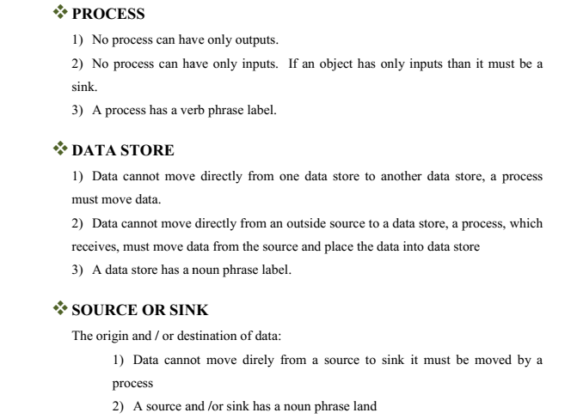

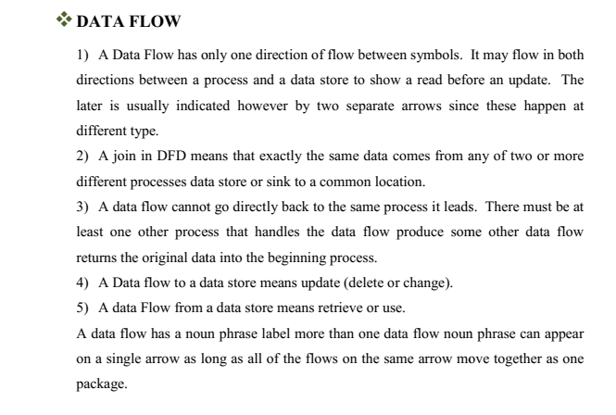

**6.4 DFD for UMS System**

* Context Level DFD**:**

The figure below shows a context Data Flow Diagram that is drawn for a School Management System. It contains a process (shape) that represents the system to model, in this case, the ***“School Management System”.*** It also shows the participants who will interact with the system, called the external entities. In this diagram, *Admin*, *Teacher and Staff* are the entities who will interact with the system. In between the process and the external entities, there are data flow (connectors) that indicate the existence of information exchange between the entities and the system.

**School Management System**

**User**

**Output**

**Input**

**Fig 6.1: Context level DFD**

* ‘0’ (zero) Level DFD

**Admin**

**Admin**

**Admission details Admission details**

**School Management System**

**Mark & Attendance details**

**Teacher**

**Teacher**

**Get Mark & Attendance details**

**Sell product details** **Get Sell product details**

**Staff**

**Staff**

**Student details**

**Student**

**Student**

**Enquiry about admission Get admission**

**Fig 6.2: ‘0’ level DFD**

* First Level DFD

**Subject, Teacher, Staff, Notice, Committee**

Add

**Processing**

**Admin**

**Applied student, View std, waiting std, all std**

**Decision Database**

result

**Output**

**Publish result, resolve result**

Salary

**Teacher, Staff**

**Fig 6.3: First level DFD**

**View & take attendance**

**Teacher**

**Add & View marks**

**Database**

**View Student**

**Output**

**6.6 Sequence Diagram**

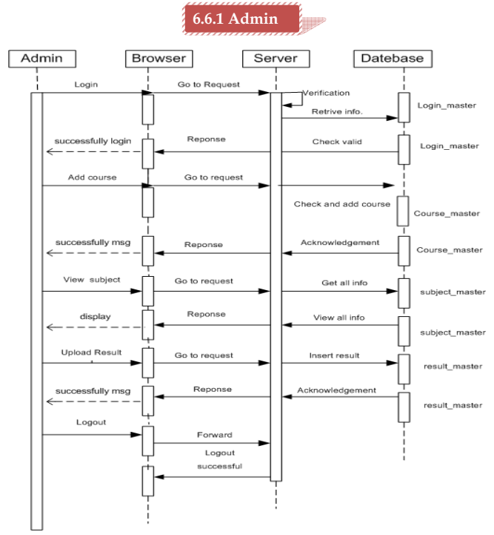

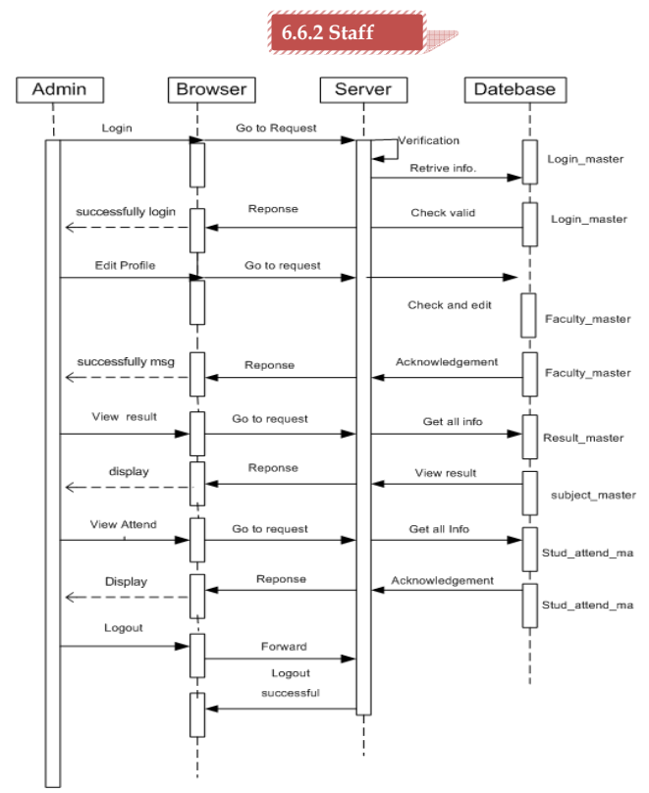

**6.7 Activity Diagram**

